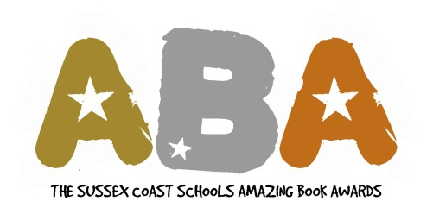

Subscription 2014

Name of School:

Contact Name: Email address:

Estimated number of students taking part:

Subscription to The Sussex Coast Schools Amazing Book Awards is: £50

Please make cheques payable to: Shoreham Academy

Addressed to: Rachel Johnson
Shoreham Academy
Kingston Lane
Shoreham-by-Sea
West Sussex
BN43 6YT

Any enquiries regarding subscriptions to: rachel.johnson@shoreham-academy.org

Subscriptions should be received at Shoreham Academy by 3rd October 2013

Timescale
- ABA Welcome Meeting: To be confirmed…
- Subscription Deadline: Thursday 3rd Oct 2013
- Long List A Announced: Tuesday 5th November 2013
- Long List feedback from schools deadline: Monday 13th January 2014
- ABA Long List Meeting: Wednesday 15th January 2014
- Long List B Announced: Monday 20th January 2014
- Shortlist Voting Deadline: Friday 7th Feb 2014
- Shortlist Announced: Monday 10th Feb 2014
- Order from the Book Nook from: Monday 10th Feb 2014
- Final Votes Deadline: Tuesday 24th June 2014
- Awards Night: Friday 11th July2014
General enquiries to: aphelan@worthinghigh.net, rachel.johnson@shoreham-academy.org, sbaker@durring.com, guilel@st-andrews-boys.org.uk

