Amazing Book Awards Shortlist Order Form

Name of School:
Contact Name:
Email:
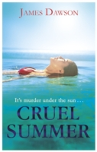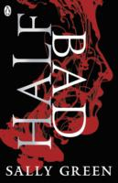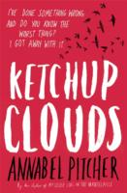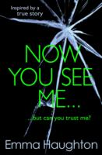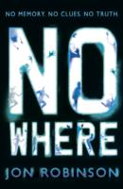
Title | Price | Quantity
Cruel Summer | £7.99 £6.39
Half Bad | £7.99 £6.39
Ketchup Clouds | £6.99 £5.59
Now You See Me… | £6.99 £5.59
Nowhere | £6.99 £5.59
 | Total Books

To ensure you have the shortlist for the awards either email vanessalewis@booknookuk.com or call 01273 911988 to place your order.
20% discount is applied to all orders.
Many thanks and happy reading!

Vanessa Lewis
The Book Nook

