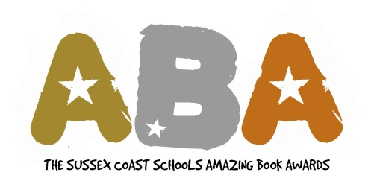

Subscription 2013

Name of School:

Contact Name: Email address:

Estimated number of students taking part:

Subscription to The Sussex Coast Schools Amazing Book Awards is: £50

Please make cheques payable to: Shoreham Academy

and address to: Rachel Johnson
Shoreham Academy
Kingston Lane
Shoreham-by-Sea
West Sussex
BN43 6YT

Any enquiries regarding subscriptions to: rachel.johnson@shoreham-academy.org

Subscriptions should be received at Shoreham Academy by 26th October 2012

Timescale

- Subscriptions received at Shoreham Academy by 26th October 2012
- 1st November - long list (A) sent to each school for librarian feedback. Feedback returned by 14th January.
- 21st January – Long List (B) sent to schools for students to vote for their 5 favourites to form the short list. All votes returned by 4th February.
- 7th March – WBD - ABA short list announced
- 8th March order books from The Book Nook, 20% discount on rrp
- Once your books arrive, start reading!
- 18th June finish reading and voting
- 5th July - Presentation Evening at Shoreham Academy

General enquiries to: aphelan@worthinghigh.net, rachel.johnson@shoreham-academy.org, sbaker@durring.com, guilel@st-andrews-boys.org.uk

