Amazing Book Awards Long List Order Form
Name of School:
Contact Name:
Email:
Title | Price | Quantity
- VIII by H. M. Caster | £5.59
- Blood Red Road by Moria Young | £6.39
- Cracks by Caroline Green | £5.59
- Daylight Savings by Edward Hogan | £5.59
- Dead Time by Anne Cassidy | £5.59
- The Fury by Alexander Gordon Smith | £6.39
- Mister Creecher by Chris Priestley | £5.59
- Momentum by Saci Lloyd | £5.59
- a)A Monster Calls (illustrated version) by Patrick Ness  b) A Monster Calls (non illustrated) by Patrick Ness | £7.19  £5.59
- The Repossession by Sam Hawksmoor | £5.59
- Saving Daisy by Phil Earle | £5.59
- Six Days by Philip Webb | £5.59
- Slated by Teri Terry | £5.59
- Unrest by Michelle Harrison | £5.59
- Wolf Blood by N.M. Browne | £5.59
 | Total Books

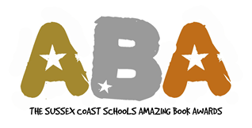
You can either email info@booknookuk.com or call 01273 911988 to place your order.
All prices include 20% discount.
Many thanks. Vanessa Lewis

