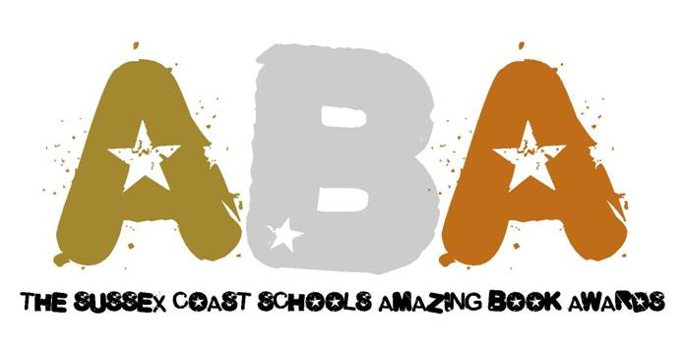

Recommendations for Long List 2014

Date for your diary - presentation evening: 11th July 2014
The criteria

- A book of fiction
- A book published between 1st June 2012 and 31st May 2013
- Must be paperback editions
- Must be published in the UK for the first time in paperback
- Author must be a UK resident
- Editions from a series excluded (1st parts are fine)
- Must be appropriate for years 9 – 10 (age 13 to 15)
- Recommendations for long list returned by end of September 2013

Title | Author

Recommendation from: | Email:

Please email your recommendations to Amanda Phelan at Worthing High School aphelan@worthinghigh.net

Check out the website for more information: http://amazingbookawards.co.uk/

